Lab 06 – Worksheet

Name: Hatim Shabbir | Arsheel Abbas | ID: hs11045 | aa11163 | Section: T2

Note: Assumptions and logics should be explained separately in tasks after the task results.

Github:
https://github.com/Hatim1947/Lab06-Git-ArsheelAbbasANDHatimShabbir.git

Task 1
Block Diagrams
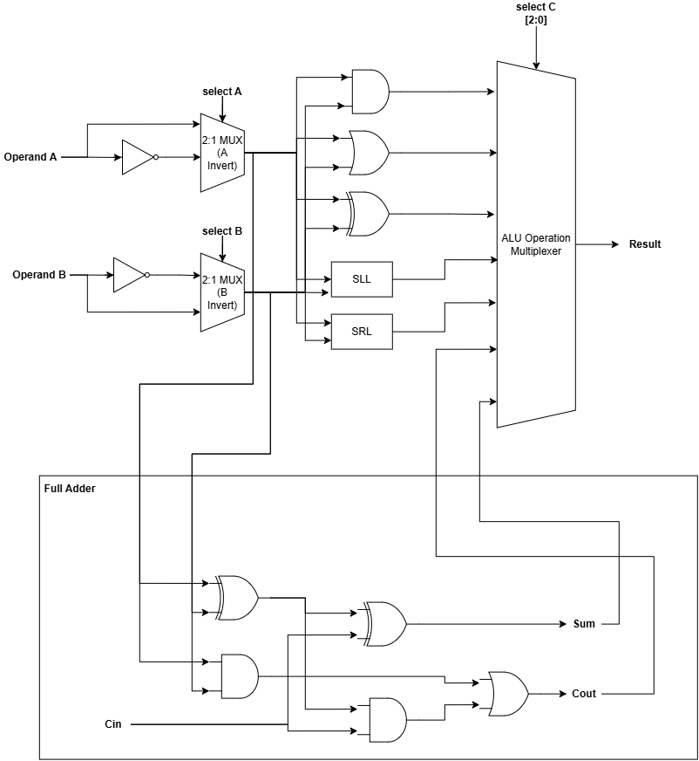

Comments
Addition and subtraction share the same Full Adder, with subtraction executed by inverting Operand B via its 2:1 MUX and setting Carry-In to 1. Consequently, the final ALU multiplexer requires a 3-bit control signal (select C [2:0]) to accommodate the 7 physical data paths.

Task 2

Modules + Testbench:
Top Module:
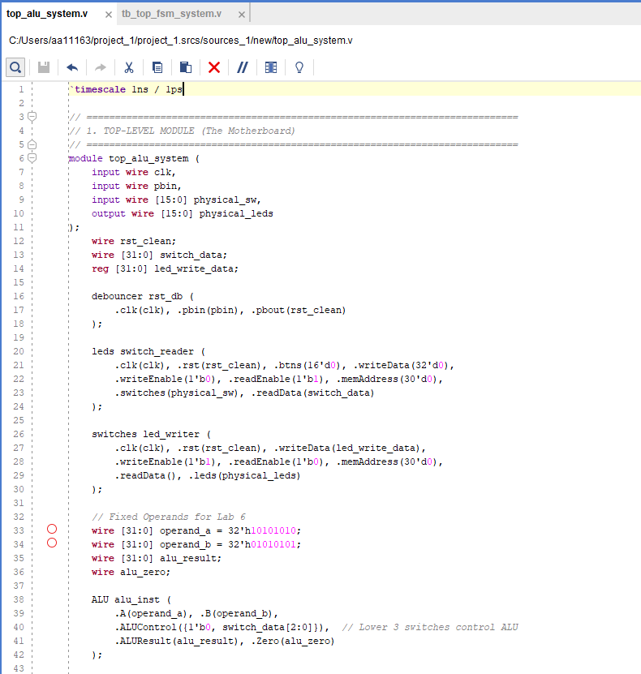
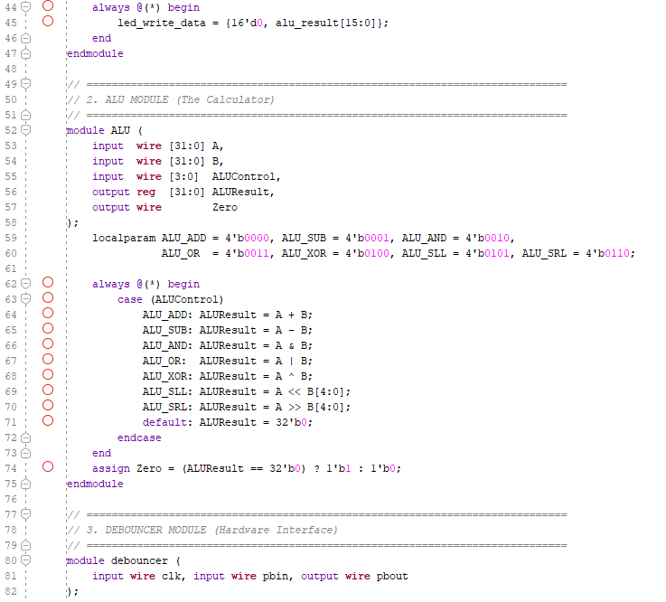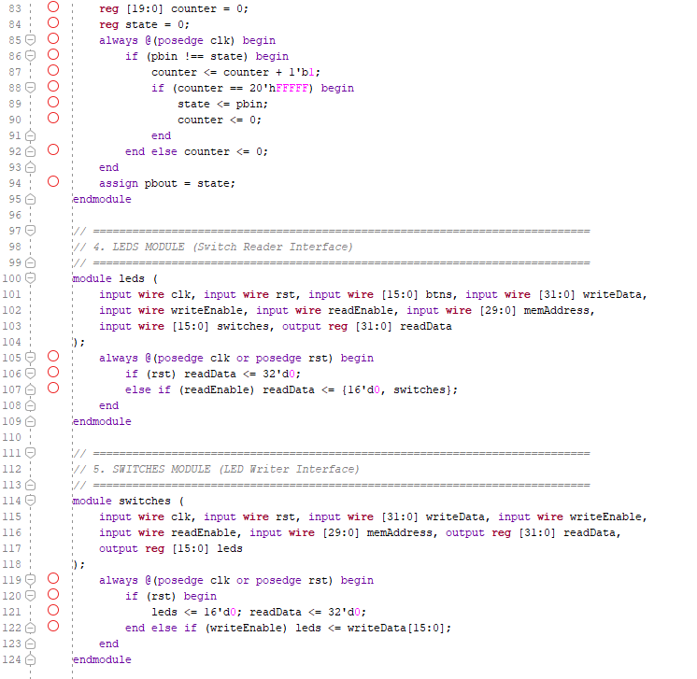

TestBench:
`timescale 1ns / 1ps

module ALU_tb;
reg [31:0] A;
reg [31:0] B;
reg [3:0] ALUControl;
wire [31:0] ALUResult;
wire Zero;

// Instantiate ONLY the ALU for mathematical testing
ALU uut (
.A(A), .B(B), .ALUControl(ALUControl), .ALUResult(ALUResult), .Zero(Zero)
);

initial begin
A = 32'h00000010; B = 32'h00000005; ALUControl = 4'b0000; #10; // ADD
A = 32'h00000010; B = 32'h00000010; ALUControl = 4'b0001; #10; // SUB (Zero=1)
A = 32'h0000FFFF; B = 32'h00000F0F; ALUControl = 4'b0010; #10; // AND
A = 32'h0000F0F0; B = 32'h00000F0F; ALUControl = 4'b0011; #10; // OR
A = 32'hFFFFFFFF; B = 32'h0000FFFF; ALUControl = 4'b0100; #10; // XOR
A = 32'h00000001; B = 32'h00000002; ALUControl = 4'b0101; #10; // SLL
A = 32'h00000008; B = 32'h00000002; ALUControl = 4'b0110; #10; // SRL
$finish;
end
endmodule

Results:
(Alu result of AND)
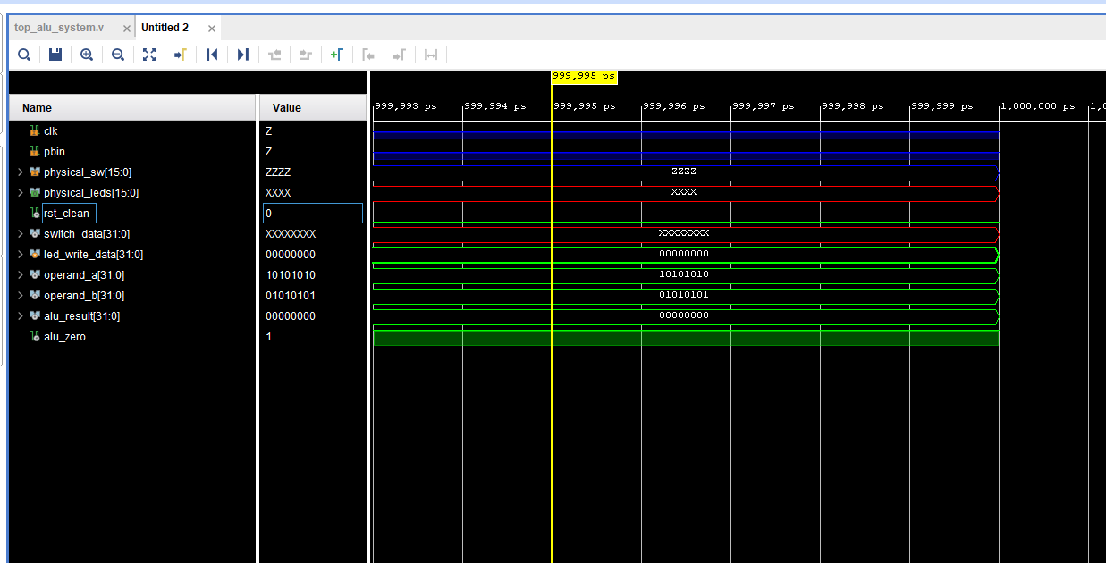

Task 3

RTL Schematics
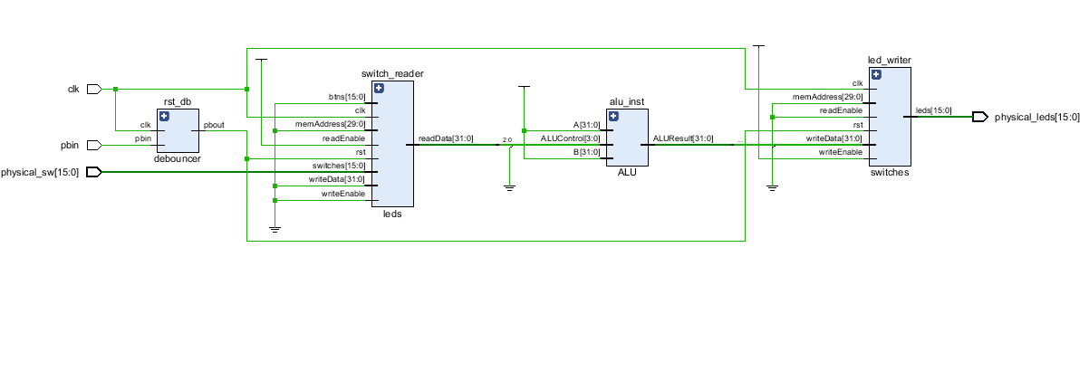
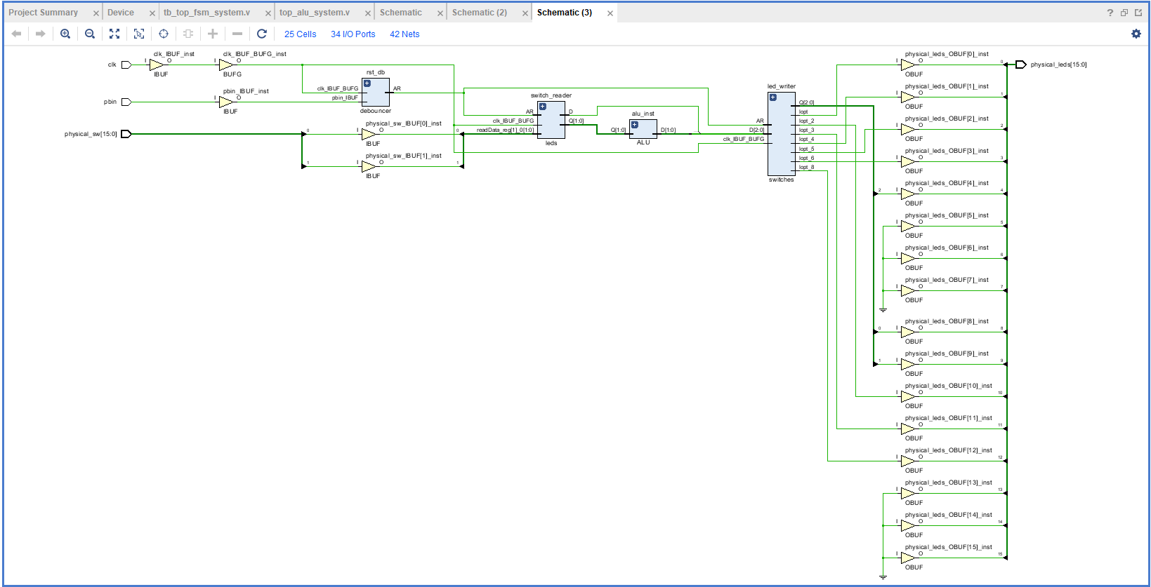

Lab 05 – Designing FSM Using FPGA Switches and LEDs

Assessment Rubrics

Points Distribution
Task No. | LR2  Code | LR 5  Results | LR11  Design | AR7
Task 1 | - | - | /20 | /20
Task 2 | /20 | /15 |  | /20
Task 3 | /10 | /15 |  | /20
Total Points | /80 |  |  | /20
CLO Mapped | CLO 1
For description of different levels of the mapped rubrics, please refer the provided Lab Evaluation Assessment Rubrics and Affective Domain Assessment Rubrics.
# | Assessment Elements | Level 1: Unsatisfactory  Points 0-1 | Level 2: Developing  Points 2 | Level 3:Good  Points 3 | Level 4:Exemplary  Points 4
LR2 | Program/Code/ Simulation Model/ Network Model | Program/code/simulation model/network model does not implement the required functionality and has several errors. The student is not able to utilize even the basic tools of the software. | Program/code/simulation model/network model has some errors and does not produce completely accurate results. Student has limited command on the basic tools of the software. | Program/code/simulation model/network model gives correct output but not efficiently implemented or implemented by computationally complex routine. | Program/code/simulation /network model is efficiently implemented and gives correct output. Student has full command on the basic tools of the software.
LR5 | Results & Plots | Figures/ graphs / tables are not developed or are poorly constructed with erroneous results. Titles, captions, units are not mentioned. Data is presented in an obscure manner. | Figures, graphs and tables are drawn but contain errors. Titles, captions, units are not accurate. Data presentation is not too clear. | All figures, graphs, tables are correctly drawn but contain minor errors or some of the details are missing. | Figures / graphs / tables are correctly drawn and appropriate titles/captions and proper units are mentioned. Data presentation is systematic.
AR9 | Report | All the in-lab tasks are not included in report and / or the report is submitted too late. | Most of the tasks are included in report but are not well explained. All the necessary figures / plots are not included. Report is submitted after due date. | Good summary of most the in-lab tasks is included in report. The work is supported by figures and plots with explanations. The report is submitted timely. | Detailed summary of the in-lab tasks is provided. All tasks are included and explained well. Data is presented clearly including all the necessary figures, plots and tables.

